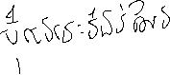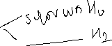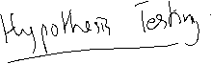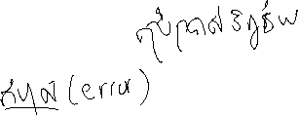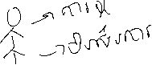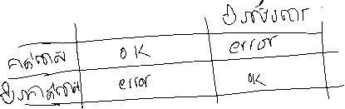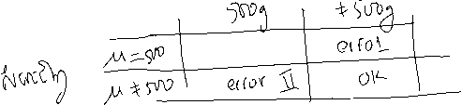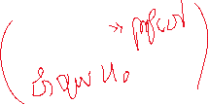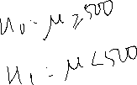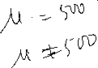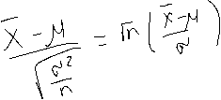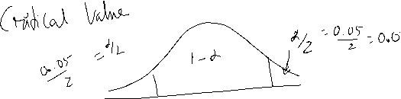

1. Jamestown Steel Company manufactures and assembles desks and other office equipment at several plants in western New York State. The weekly production of the Model A325 desk at the Fredonia Plant follows a normal probability distribution with a mean of 200 and a standard deviation of 16.  
   Recently, because of market expansion, new production methods have been introduced and new employees hired. The vice president of manufacturing would like to investigate whether there has been a change in the weekly production of the Model A325 desk. Is the mean number of desks produced at the Fredonia Plant different from 200 at the .01 significance level?

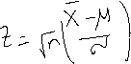

We take a sample from the population (weekly production), compute a test statistic, apply the decision rule, and arrive at a decision to reject H0 or not to reject H0. The mean number of  
desks produced last year (50 weeks because the plant was shut  
down 2 weeks for vacation) is 203.5. The standard deviation of  
the population is 16 desks per week. Computing the z value

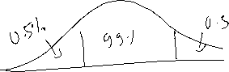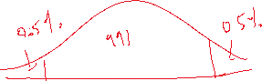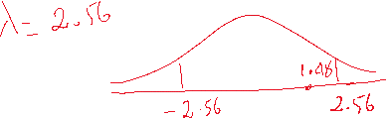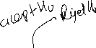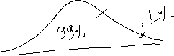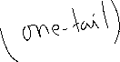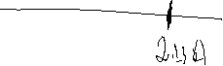

1. Heinz, a manufacturer of ketchup, uses a particular machine to dispense 16 ounces of its ketchup into containers. From many years of experience with the particular dispensing machine, Heinz knows the amount  
   of product in each container follows a normal distribution with a mean of 16 ounces and a standard deviation of 0.15 ounce. A sample of 50 containers filled last hour revealed the mean amount per container was 16.017  
   ounces. Does this evidence suggest that the mean amount dispensed is different from 16 ounces? Use the .05 significance level.

(a) State the null hypothesis and the alternate hypothesis.  
(b) What is the probability of a Type I error?  
(c) Give the formula for the test statistic.  
(d) State the decision rule.  
(e) Determine the value of the test statistic.  
(f) What is your decision regarding the null hypothesis?  
(g) Interpret, in a single sentence, the result of the statistical test.

1. Refer to exercises 2.  
   (a) Suppose the next to the last sentence is changed to read: Does this evidence suggest that the mean amount dispensed is more than 16 ounces? State the null hypothesis and the alternate hypothesis under these conditions.  
   (b) What is the decision rule under the new conditions stated in part (a)?  
   (c) A second sample of 50 filled containers revealed the mean to be 16.040 ounces. What is the value of the test statistic for this sample?  
   (d) What is your decision regarding the null hypothesis?  
   (e) Interpret, in a single sentence, the result of the statistical test.  
   (f ) What is the p-value? What is your decision regarding the null hypothesis based on the p-value? Is this the same conclusion reached in part (d)?
2. The McFarland Insurance Company Claims Department reports the mean cost to  
   process a claim is $60. An industry comparison showed this amount to be larger  
   than most other insurance companies, so the company instituted cost-cutting measures. To evaluate the effect of the cost-cutting measures, the supervisor of the  
   Claims Department selected a random sample of 26 claims processed last month and recorded the cost to process each claim. The sample information is reported below. At the .01 significance level, is it reasonable to conclude that the mean cost to process a claim is now less than $60?

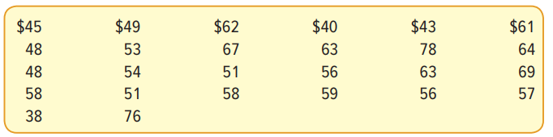

1. The mean life of a battery used in a digital clock is 305 days. The lives of the batteries follow the normal distribution. The battery was recently modified to last longer. A sample of 20 of the modified batteries had a mean life of 311 days with a standard deviation of 12 days. Did the modification increase the mean life of the battery?  
   (a) State the null hypothesis and the alternate hypothesis.  
   (b) Show the decision rule graphically. Use the .05 significance level.  
   (c) Compute the value of t. What is your decision regarding the null hypothesis? Briefly summarize your results.

